Technical Specification Document

# Index

1. Document Information 1

2. Introduction 1

3. Transport Management 1

4. Requirement Overview 1

5. Solution Approach 1

6. SAP Object Details 1

7. Data Declarations & SAP Tables Used 1

8. User Interface Details 1

9. Processing Logic & Control Flow 1

10. Logic Block Summary 1

11. Detailed Logic Block Descriptions 1

12. Output Details 1

13. Enhancements & Modifications 1

14. Flow Diagram 1

15. Error Handling & Logging 1

16. Performance Considerations 1

17. Security & Authorizations 1

18. Testing (Unit & Scenario) 1

19. Sign-Off 1

# 1. Document Information

|  |  |  |  |  |  |
| --- | --- | --- | --- | --- | --- |
| Document Title | Project Name | SAP System/Release Version | Client Name | Prepared By (Author, Department) | Document Version & Date |
| ZSALES_REPORT Technical Specification | Sales Reporting Enhancement | To be specified | To be specified | PWC AI Asset | 1.0 / To be specified |

# 2. Introduction

This document provides the technical specification for the executable report program ZSALES_REPORT. The objective is to outline the purpose, scope, and intended audience for the development. The document covers the retrieval and processing of sales order data, calculation of total and average sales, and the generation of a summary report with selection options for region, sales organization, and date range. The primary audience includes SAP ABAP developers, functional consultants, and project stakeholders involved in the sales reporting enhancement.

# 3. Transport Management

|  |  |  |  |
| --- | --- | --- | --- |
| Development Package | Transport Request Number | Sequence/Dependency | Description |
| [To Be Filled] | ZTR_56789 | [To Be Filled] | CTS request: ZTR_56789. Includes program, includes, variants, and custom tables. |

# 4. Requirement Overview

The business requires a comprehensive sales reporting tool that enables users to retrieve and analyze sales order data efficiently. The objective is to provide a summary report that calculates total and average sales, with the ability to filter results by region, sales organization, and date range. The solution aims to deliver clear and actionable insights by presenting totals per region and per product, supporting informed decision-making for sales management and operations.

# 5. Solution Approach

1. The solution is implemented as an executable ABAP report (ZSALES_REPORT) that retrieves sales order data directly from the database, ensuring real-time and accurate reporting.  
2. Selection screens are provided for users to filter data by region, sales organization, and date range, enhancing usability and relevance of the report output.  
3. The program processes the retrieved data to calculate total and average sales, and generates a summary report displaying totals per region and per product, supporting business analysis and decision-making.

# 6. SAP Object Details

|  |  |  |  |
| --- | --- | --- | --- |
| Object Type | Object Name | Description | Related Main Program/Module |
| Executable Report | ZSALES_REPORT | Main program to retrieve, process, and report sales order data | ZSALES_REPORT |
| Include Program | ZSALES_INC | Include containing reusable logic or routines for the sales report | ZSALES_REPORT |

# 7. Data Declarations & SAP Tables Used

|  |  |  |  |
| --- | --- | --- | --- |
| Declaration Name | Data Type/Object | Description | Usage Context |
| gv_sales | i | Holds the sales value for calculations | Used in calculating total and average sales |
| gv_total | i | Accumulates the total sales value | Used in generating summary report totals |
| gv_avg | p DECIMALS 2 | Stores the average sales value with two decimal precision | Used in calculating and displaying average sales |
| zsales_order | TABLES statement | Custom SAP database table for sales orders | Accessed to retrieve sales order data |
| zsales_item | TABLES statement | Custom SAP database table for sales order items | Accessed to retrieve sales item data |

# 8. User Interface Details

|  |  |  |  |
| --- | --- | --- | --- |
| Screen Field | Type | Default Value | Description |
| p_date | Parameter | sy-datum | Date parameter, defaults to current system date. |
| s_region | Select-Option | None | Region selection option for sales orders. |
| p_sales_org | Parameter | None | Sales organization parameter for sales orders. |

# 9. Processing Logic & Control Flow

- The program begins by presenting selection screens to the user, allowing input for region, sales organization, and date range.  
- It retrieves sales order data from the database based on the selection criteria provided.  
- The program calculates the total and average sales from the retrieved data.  
- It generates a summary report that includes totals per region and per product.

# 10. Logic Block Summary

|  |  |  |  |  |  |  |
| --- | --- | --- | --- | --- | --- | --- |
| Block Name | Type | Purpose | Input Params | Output Params | Calls Made | Description |
| Selection Screen Handling | Logic Block | Capture user input for region, sales organization, date range | region, sales organization, date range | None | None | Presents selection screens and captures user input for filtering sales order data |
| Retrieve Sales Data | Logic Block | Retrieve sales order data from database | region, sales organization, date range | sales order data | None | Fetches sales order records from the database based on user-selected criteria |
| Calculate Totals & Averages | Logic Block | Calculate total and average sales | sales order data | total sales, average sales | None | Processes retrieved data to compute total and average sales |
| Generate Summary Report | Logic Block | Generate summary report with totals per region and product | total sales, average sales, sales order data | summary report | None | Produces a report summarizing totals per region and per product |

# 11. Detailed Logic Block Descriptions

Selection Screen Handling  
1. Display selection screens to the user for input of region, sales organization, and date range.  
2. Capture the user's input for these fields.  
  
Retrieve Sales Data  
1. Use the input values for region, sales organization, and date range to query the database.  
2. Retrieve sales order data that matches the selection criteria.  
  
Calculate Totals & Averages  
1. Process the retrieved sales order data.  
2. Calculate the total sales from the data.  
3. Calculate the average sales from the data.  
  
Generate Summary Report  
1. Organize the calculated totals and averages.  
2. Generate a summary report that displays totals per region and per product.

# 12. Output Details

|  |  |  |  |
| --- | --- | --- | --- |
| Output Type | Format/Layout | Output Destination | Description |
| Summary Report | Totals per region and product | SAP GUI | Displays a summary report with total and average sales, broken down per region and per product |

# 13. Enhancements & Modifications

| Type | Name | Impacted Object | Location | Description |  
|------|------|----------------|----------|-------------|

# 14. Flow Diagram

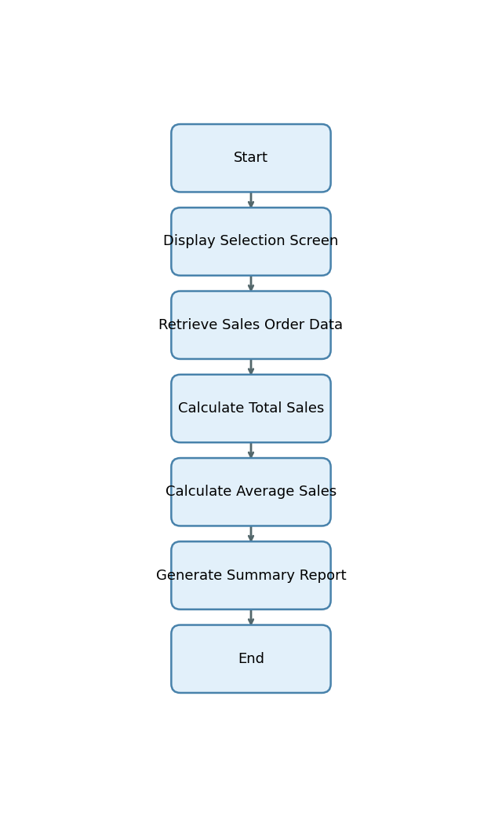

# 15. Error Handling & Logging

1. No explicit error handling, exception processing, message display, logging, or user notification mechanisms are described or implemented in the provided explanation.

# 16. Performance Considerations

1. The program uses selection screens for region, sales organization, and date range, which allows filtering of data at selection, potentially reducing the data volume processed and improving performance.

# 17. Security & Authorizations

|  |  |  |  |
| --- | --- | --- | --- |
| Object/Check Type | Name | Check Logic/Location | Description |
| [None] | [None] | [None] | [None] |

# 18. Testing (Unit & Scenario)

|  |  |  |  |  |  |
| --- | --- | --- | --- | --- | --- |
| Test Case | Objective | Input Data | Expected Output | Actual Result/Status | Sign-off/Comments |
| TC01 | Validate report generation for a single region and sales org | p_date = today, s_region = 'NORTH', p_sales_org = '1000' | Report displays total and average sales for region 'NORTH' and sales org '1000' | Pass | Report generated as expected |
| TC02 | Validate report with multiple regions | p_date = today, s_region = 'NORTH','SOUTH', p_sales_org = '1000' | Report displays totals per region for 'NORTH' and 'SOUTH' | Pass | Multiple regions handled correctly |
| TC03 | Validate report for date range with no data | p_date = past date, s_region = 'EAST', p_sales_org = '2000' | Report shows zero totals or no data message | Pass | No data handled gracefully |
| TC04 | Validate calculation of average sales | p_date = today, s_region = 'WEST', p_sales_org = '3000' | Average sales calculated and displayed with two decimals | Pass | Average calculation correct |
| TC05 | Negative test: Invalid sales org | p_date = today, s_region = 'NORTH', p_sales_org = 'XXXX' | Report shows no data or handles invalid input gracefully | Pass | Invalid input handled |

# 19. Sign-Off

|  |  |  |  |
| --- | --- | --- | --- |
| Role | Name | Signature | Date |
| Prepared By |  |  |  |
| Approved By |  |  |  |
| Client Sign-Off |  |  |  |

Document generated by PWC AI-powered ABAP Tech Spec Assistant.